Installation and Operating Instructions

TransMATTer Transmitter
Model MAT4-SS

Installation
- Place the mat where it will be stepped on anywhere except the very edge. The water resistant material used to manufacture the TransMATTer is required to have a protective cover over it; this would usually consist of a door rug or similar covering.
- The transmitter that is connected to the TransMATTer must not be mounted directly to a metallic surface. Doing so will severely reduce the range of the transmitter.
- The TransMATTer is intended for indoor use only.

Operation
- Whenever the mat is stepped on, the Red LED on the face of the TransMATTer Signature Series transmitter will light up. The transmitter then sends a signal to any Signature Series Receiver, activating the Receiver and illuminating the Doorbell LED and Indicator symbol.
- Transmission range is determined by which Signature Series receiver you are using, and will vary from 250 feet up to 2000 feet.
- If pressure is maintained, the transmitter will continue to transmit until pressure is removed from the mat.
CAUTION: When handling or shipping the TransMATTer, do not bend the mat sharply or fold it. It must be kept flat or rolled loosely or it will be damaged.

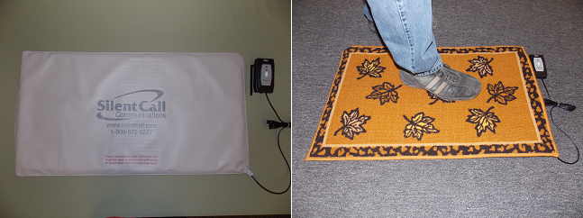

Address Switch Settings
The Silent Call system is digitally encoded. All Silent Call receivers and transmitters are tested and leave the factory programmed to a factory default address. You do not need to change the address unless someone in your area has Silent Call products and they are interfering with your equipment.

- Make sure that all Silent Call transmitters in the area are turned off.
- Located on the back of the transmitter case is a removable access panel. Remove the access panel and take out the batteries. Note that you MUST remove the batteries first or the switch setting will not take effect.
- Locate the address switch on the transmitter circuit board that has 5 small dip switches. Set the switches to any combination that you want. For Example: 1, 2 ON 3, 4, 5 OFF. This gives your transmitter an “address”. Note: Do not set the switches to the all “ON” or all “OFF” position.
- Reinstall the batteries and replace the access panel.
- Refer to your specific Signature Series Receiver instruction manual for programming your receiver to your newly changed transmitter address.

Technical Support
For technical support on this or any other Silent Call product, please feel free to contact us. You can reach us by phone at 800-572-5227 (voice or TTY) or by Email at support@silentcall.com

Limited Warranty
The transmitter itself is warranted to be free of defects in material and workmanship for five years from the date of initial purchase. The pressure sensitive mat is warranted for one year. During that time, the unit will be repaired or replaced free of charge when shipped prepaid to Silent Call Communications. This warranty is void if the defect is caused by customer abuse or neglect.

